ICS 4111: Embedded Systems & IoT, Semester Project
Deliverable 3: Transmit and Visualise Sensor Data on Cloud Platforms
Group Flower Assignment: Carnations Farm: Flora Farms, Naivasha, Kenya

1. Overview
This deliverable extends our Deliverable 2 embedded device design into a full end-to-end IoT pipeline: sensor data is now transmitted from the ESP32 to InfluxDB Cloud (time-series storage) and visualised on a Grafana dashboard, so that Sheila and other stakeholders at Flora Farms can remotely monitor greenhouse conditions for the carnation greenhouse.
Device architecture (per spec):
Component | Role
ESP32 | Microcontroller, WiFi connectivity, HTTP client to InfluxDB
DHT22 | Temperature & humidity (carnation growth conditions)
MQ-5 (simulated as MQ-2 in Wokwi , see note below) | LPG / combustible gas detection (greenhouse LPG heater safety)
16x2 I2C LCD | On-site live readout for greenhouse staff
Note on the gas sensor: Wokwi's simulator does not provide a dedicated MQ-5 part, so we used the wokwi-mq2-gas-sensor part as a stand-in. The MQ-2 detects the same family of combustible gases (LPG, propane, methane) via the same analog-voltage interface as the MQ-5, so all wiring, code, and thresholds transfer directly to real MQ-5 hardware without modification.

2. Why These Metrics? (Carnation Growth + Farm Context)
Carnations (Dianthus caryophyllus) grow best in:
- Temperature: 18-22°C (growth stress above ~27°C; risk of stunted growth and increased disease susceptibility below ~10°C)
- Relative humidity: 60-70% (excess humidity promotes fungal disease such as Botrytis / grey mould, a major cut-flower crop risk)
Since Flora Farms' greenhouses are heated with LPG, we also monitor combustible gas concentration as a safety metric, an LPG leak near the heater is a fire/health hazard independent of flower growth conditions, and is exactly the kind of remote-monitoring value stakeholders like Sheila (based in Nairobi, away from the physical greenhouses) need visibility into.

3. Prototype
Type: Simulated (Wokwi) Public Wokwi project link:
https://wokwi.com/projects/469455948638270465
Files in this repo (/wokwi-carnation-monitor/):
- sketch.ino - ESP32 firmware (sensor reading, LCD display, InfluxDB write)
- diagram.json - Wokwi wiring diagram
- libraries.txt - required Arduino libraries
Wiring summary
From (ESP32) | To | Notes
3V3 | DHT22 VCC
GND | DHT22 GND
GPIO 15 | DHT22 DATA
5V/VIN | MQ-2(sim MQ-5) VCC
GND | MQ-2(sim MQ-5) GND
GPIO 34 | MQ-2(sim MQ-5) AO | ADC1 channel , safe to read with WiFi active
5V/VIN | LCD VCC
GND | LCD GND
GPIO 21 | LCD SDA | I2C
GPIO 22 | LCD SCL | I2C
How the sketch works
- Connects to WiFi (Wokwi-GUEST network in simulation).
- Every 5 seconds: reads DHT22 (temp/humidity) and MQ-5/MQ-2 (analog gas reading), evaluates them against carnation-growth and LPG-safety thresholds, and pushes a line-protocol point to InfluxDB Cloud via HTTPS POST to /api/v2/write.
- The LCD rotates every 3 seconds between an environmental screen (temp/humidity) and a gas/alert screen, so on-site staff have an immediate local readout even without checking the dashboard.
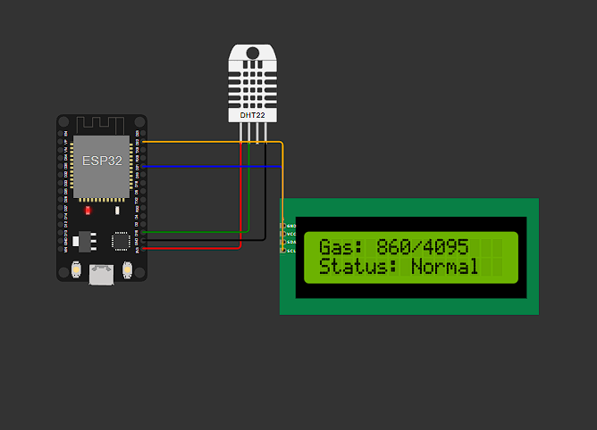
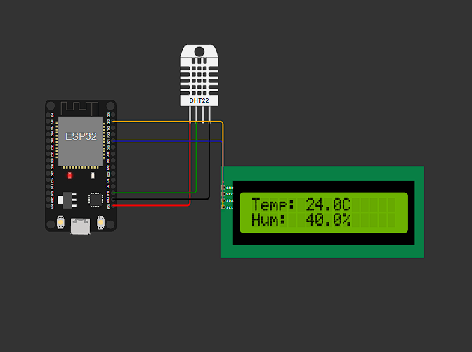

4. Cloud Storage Setup , InfluxDB Cloud
- Created a free InfluxDB Cloud account and organisation (IoT).
- Created a bucket named flora_farms_greenhouse to store all sensor data as a time-series.
- Generated an API token (Load Data → API Tokens → Generate Token) with write access scoped to this bucket, and copied it into the sketch's INFLUX_TOKEN constant (rotated/revoked prior to final submission , see security note below).
- Recorded our InfluxDB Cloud region URL (https://us-east-1-1.aws.cloud2.influxdata.com) into INFLUX_URL.
- Data is written using the InfluxDB v2 line protocol format directly over HTTP (no external client library needed , keeps the Wokwi build dependency-free):
- greenhouse_sensors,greenhouse=greenhouse_carnation_01,flower=carnation
- temperature=20.10,humidity=64.5,gas_raw=512,gas_voltage=0.412,
- temp_ok=true,humidity_ok=true,gas_alert=false
  - measurement: greenhouse_sensors
  - tags: greenhouse, flower (support filtering across groups if buckets are shared across the class)
  - fields: temperature, humidity, gas_raw, gas_voltage, temp_ok, humidity_ok, gas_alert
Verification: Data was confirmed flowing end-to-end using Grafana's Explore view against the flora_farms_greenhouse bucket, which returned a live temperature series tagged flower="carnation", greenhouse="greenhouse_carnation_01" , confirming the ESP32 → WiFi → HTTPS POST → InfluxDB Cloud write path works correctly.

5. Visualisation , Grafana Dashboard
We connected Grafana Cloud to our InfluxDB Cloud bucket as a data source (Flux query language, InfluxDB 2.x / TSM product) and built a dashboard with the following panels (dashboard JSON provided in grafana-dashboard.json for reference/import):
- Temperature over time (time-series line chart, 18-22°C optimal carnation range).
- Relative humidity over time (time-series line chart, 60-70% optimal range).
- LPG/gas sensor reading over time (time-series line chart, raw ADC value against the safety alert threshold).
- Current conditions gauge - snapshot of the latest temperature value for at-a-glance status.
Grafana dashboard link: https://ivoryhippo1867.grafana.net/d/iv4zfvg/temperature?orgId=1&from=now-6h&to=now&timezone=browser&refresh=auto
Dashboard screenshot(s):
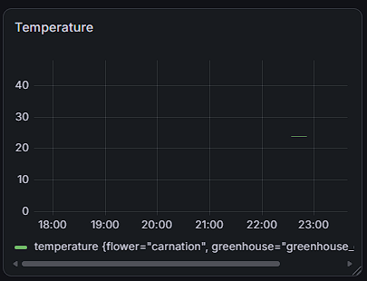
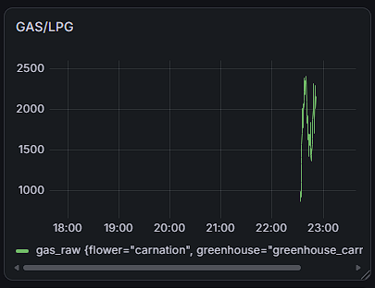
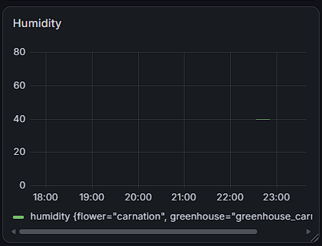

- Groupwork Evidence
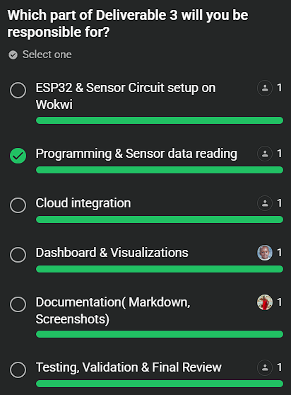
Group members:
- Gichana Ivan
- Gitahi Mathenge
- Nick Njuru
- James Muthama
- Stacy Akinyi
- Chelsea Savayi

